|  |  |  |  |  |  |
| --- | --- | --- | --- | --- | --- |
| Date | December 6, 2022 | | | Tester Name | Syed Shahabuddin |
| Environment | Penfax - Test | | | Login used |  |
| Operating System | Windows | Version: | Update: | | |
| Software Used | Edge | Version: | Update: | | |
| Select Software | Version: | Update: | | |
| Release version | 22.4.1 | | | | |
| Title | E26.03 | | | | |
| Test Type | Regression | | | | |
| Test Scenario | Receiving scheduled monthly payments with a withdrawal type of ITA minimum, specified order depletion method and moving to the next PEPP step. | | | | |
|  |  | | | | |
| Expected Results | Confirming that ITA minimum amount for the year doesn’t change, and that the minimum age factor is correct when compared to VPB PEPP talk chart of minimum age factors, even after the birthdate change.  Confirm that the PEPP rollover doesn’t interfere with the scheduled payments. | | | | |
| Pass/Fail | Pass | | | JIRA# | N/A |

Searched for a member that will be 75 soon:

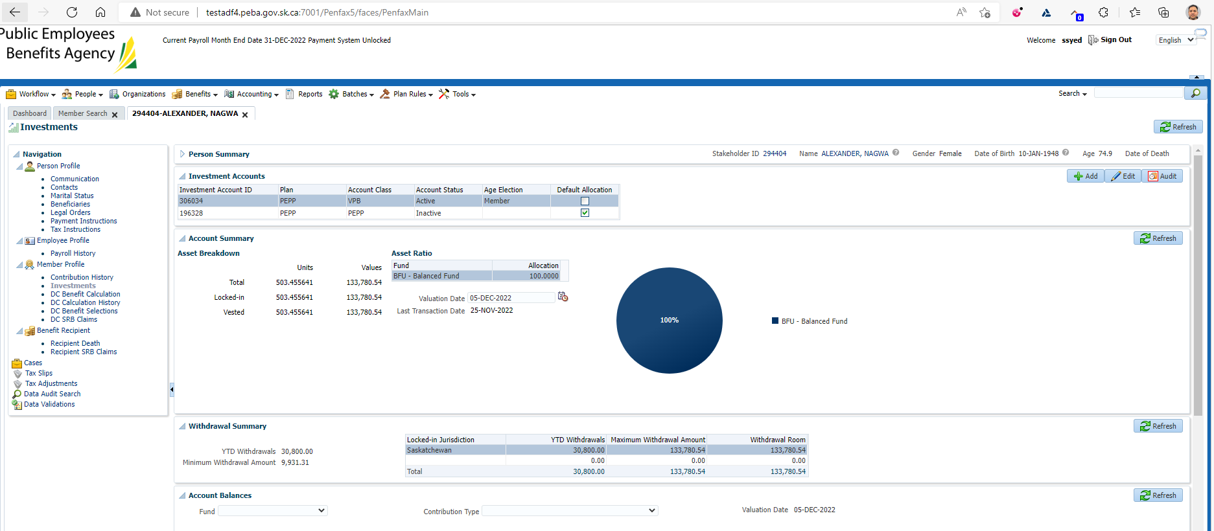

September 8, 2022

Performed interfund to Steps + Money Markey & created scheduled payment ITA minimum (specified order)

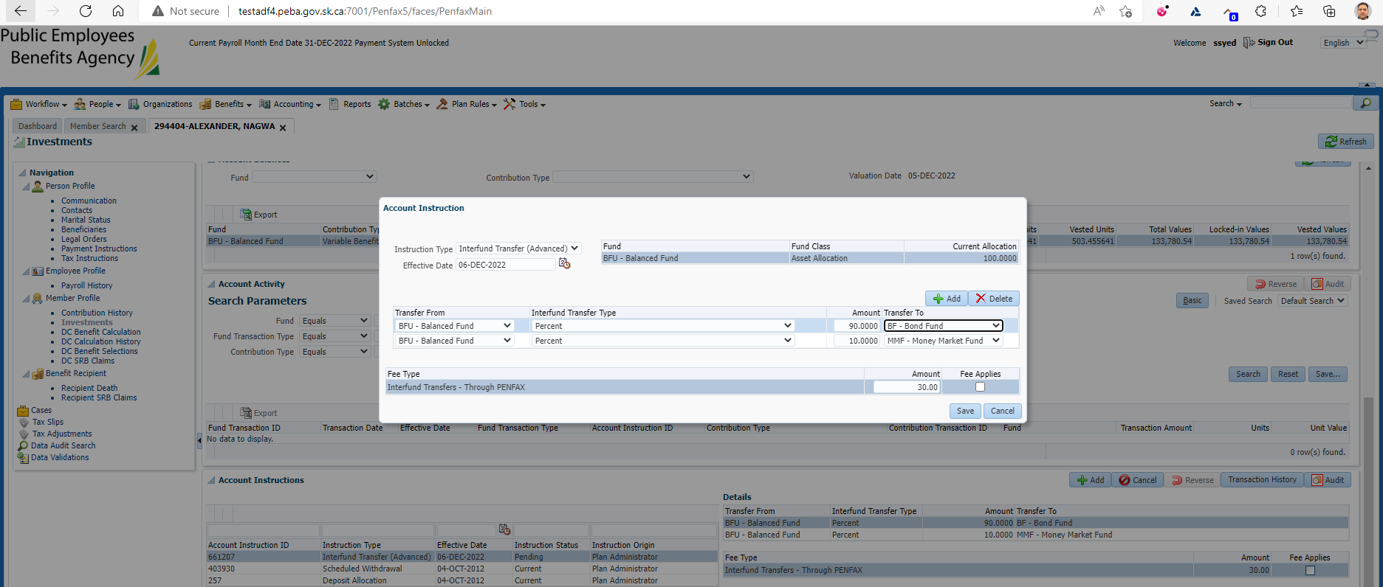

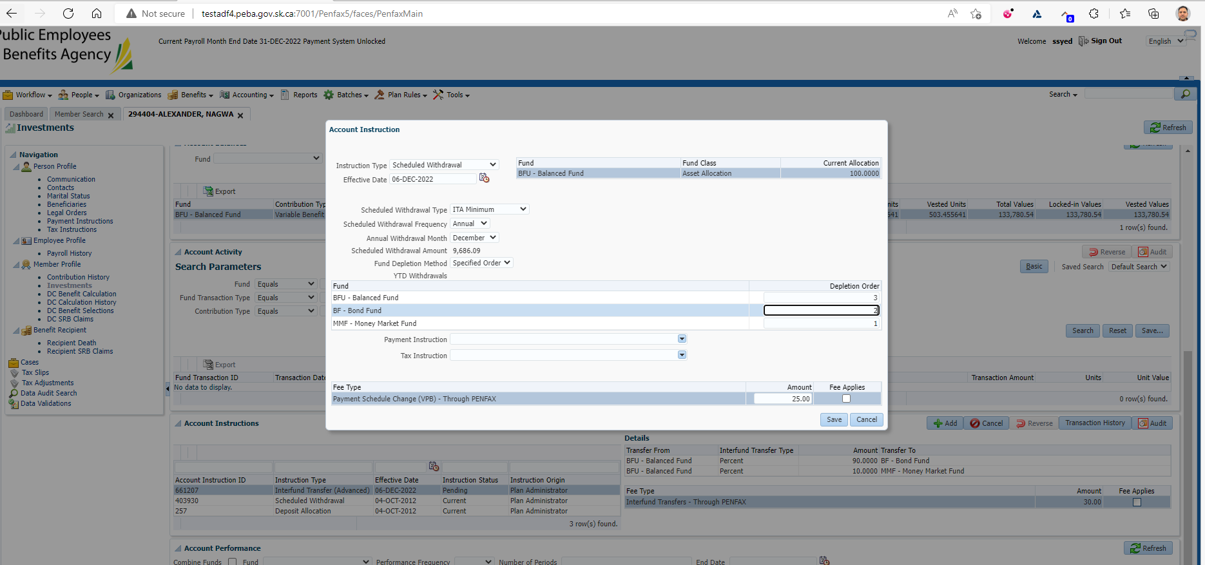

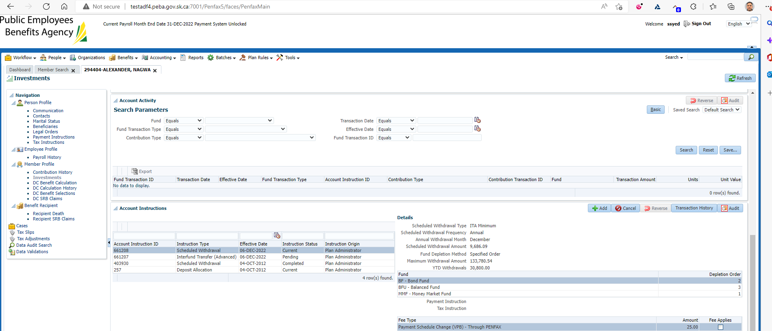

September 9, 2022 (day 2):

confirmed that interfund to Step 12 went through tomorrow & letters generated for interfund & scheduled withdrawal change.

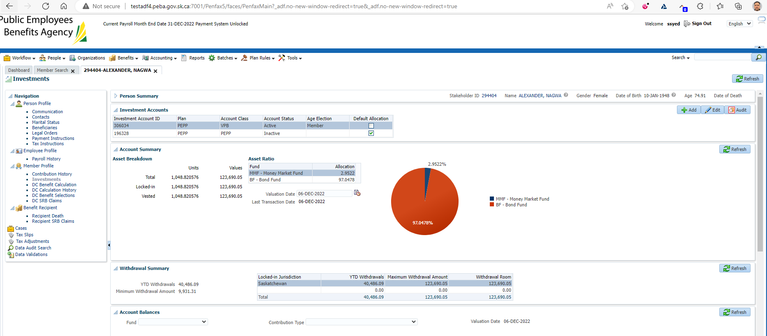

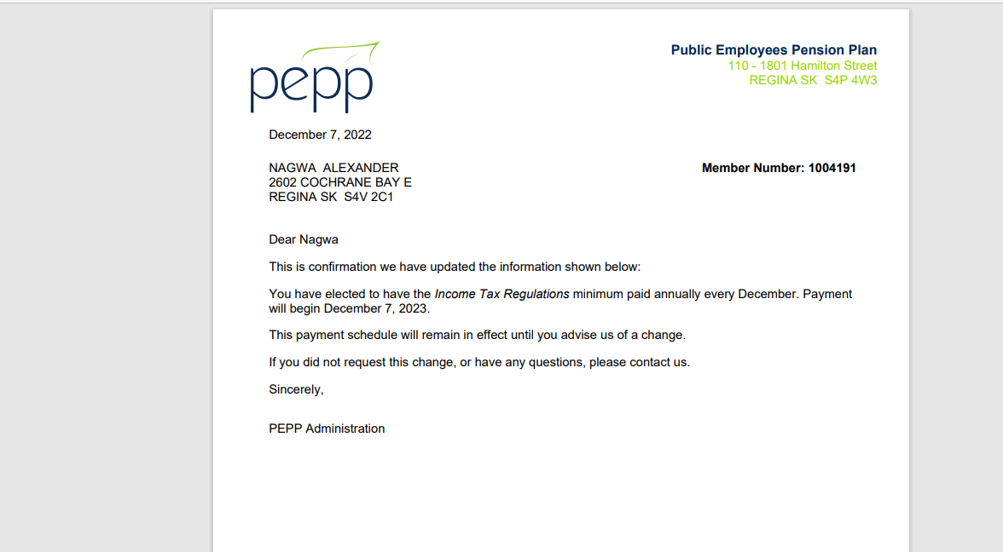

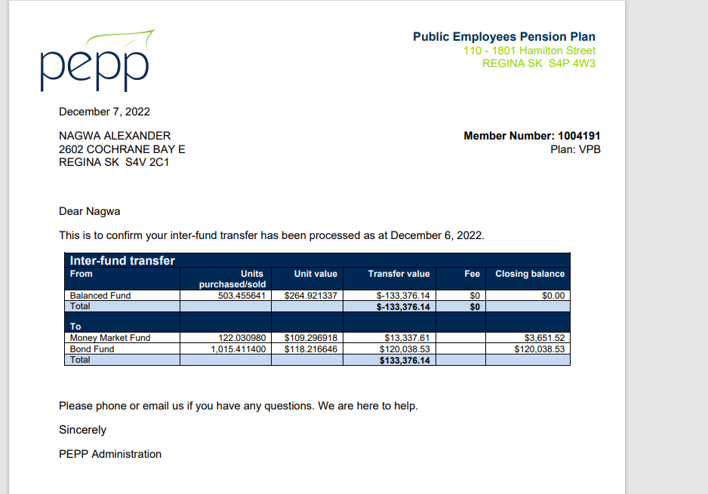

Dec 8 – confirm results:

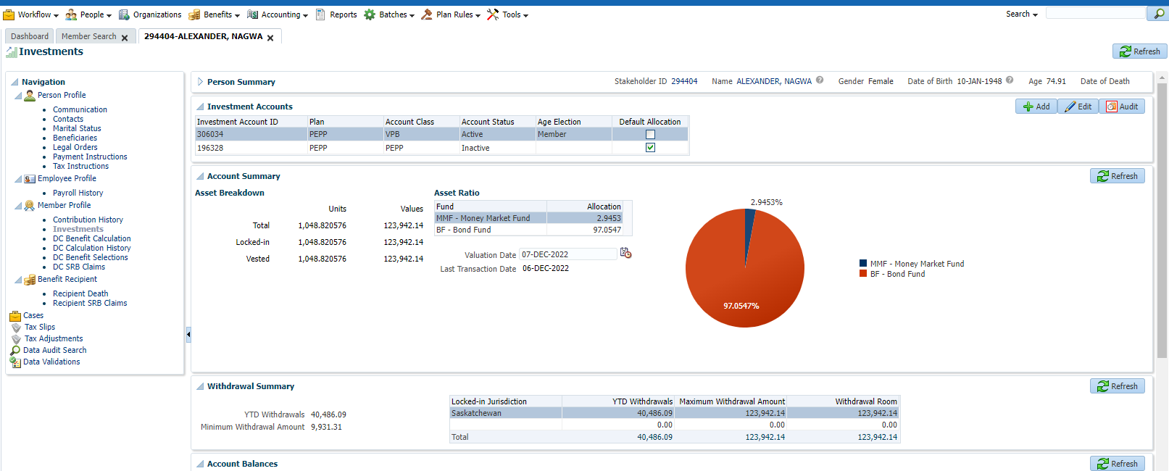

Scheduled withdrawal submitted on Dec 10, waiting for Dec 12 results

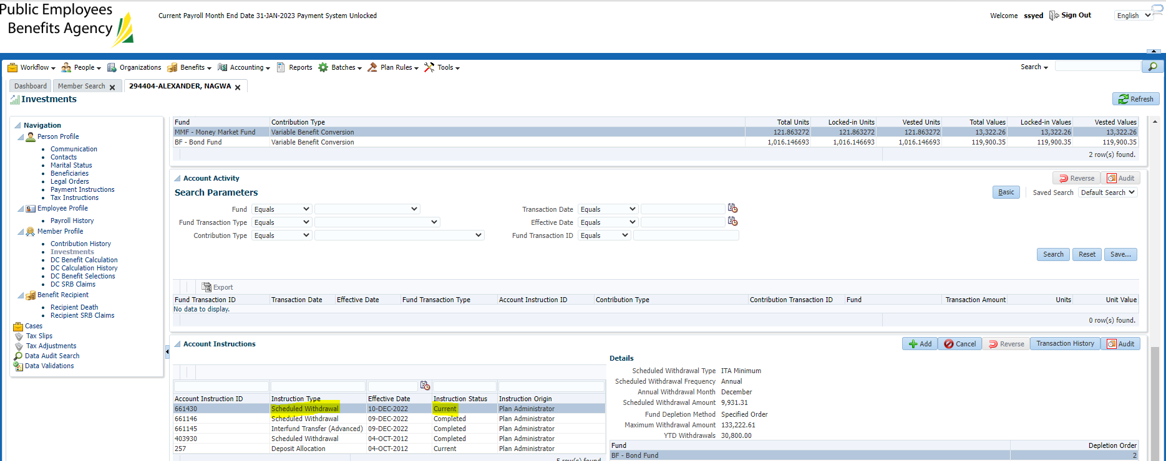

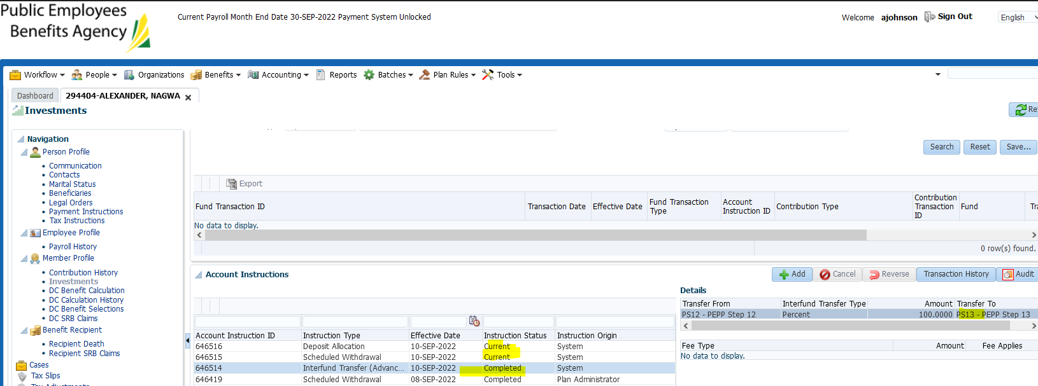

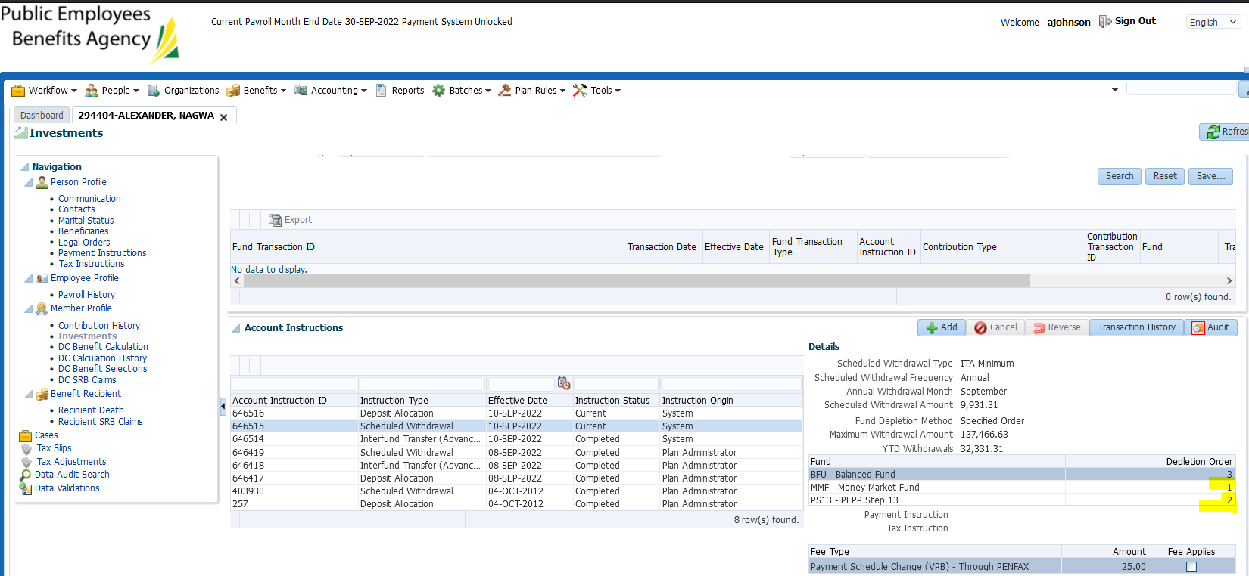

As scheduled withdrawal previously was added on date of interfund from balanced to steps, it shows three funds. This is to ensure all funds show up as specified fund order and was a fix we requested in 2022.

Confirmed if I add a new scheduled withdrawal today, I only have PS13 and MM as options. This is correct.